

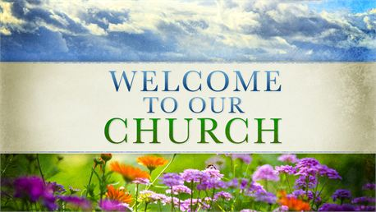

**3976 E 1400 S – Kokomo, IN 46901 – 765.395.7509**

**Sunday, April 27, 2025**

***Love as Christ Loves***

**Welcome & Opening Prayer:** Lindy Gibson

**Songs:** Alleluia Alleluia

Hosanna

**Announcements:** Lindy Gibson

**Prayer/Praise Request:** Lindy Gibson

**Offering:**

**Ushers:** Kevin & LeeAnn Mast

**Children are dismissed for Children’s Church**

K-5 goes to the Jesus and Me: (JAM Basement)

**Call to Worship/Meditation:** Lindy Gibson

**Song:** King of Kings

Oh the Blood of Jesus

**Scripture**: Romans 8:22-23, Eph. 1:3-14, Eph. 2:19-22, Heb. 9:11-15.

**Next Week’s Scripture:** Luke 7:36-50

**Message:** The New Position of Salvation

**Next Week’s Message:** The Cleansing of Salvation

**Song**: Victory in Jesus

**Benediction**: Pastor Matt

**Announcements**

Everyone is invited to attend the Annual Peace Scholarship Essay Awards Program at 5:00 pm on Sunday, May 4, at Kokomo Church of the Brethren, located at 311 W. Lincoln Rd, Kokomo, IN 46902. Three scholarships will be awarded to area high school seniors who will read their winning essays. Jeff Newton from Kokomo Urban Outreach will be our main speaker. A free will offering will be collected to support future scholarships. Refreshments following.

Pastor Matt’s weekly Bible Study is now over. He will be starting a Christianity 101 class for anyone seeking to learn! Join Pastor Matt Sunday mornings at 9 a.m. in the MYF basement starting May 4th!!

The Greentown Ministerial Association will be holding a Community VBS June 26-28th. We are looking for volunteers to set up a game booth for June 28th from 11-2 to help get the word out about Howard-Miami. Anyone interested in helping, please see Pastor Matt.

There will be Greeter training for those who are already greeters and for anyone interested in becoming one. There will be a light meal and a short training after the church service on Sunday, May 4th.

There is a Thank You card on the bulletin board in the Fellowship Hall from the Wilcox family for the donation they received from the Chili Supper.

**What’s Coming Up…**

Today: Spring Business Meeting & Carry-In

April 29: Last Buddy Bag Packing Day @ 5:30 p.m.

May 1: Women’s Sewing 9-3. Bring a sack lunch.

May 4: Christianity 101 @ 9 a.m. M.Y.F. Basement

May 4: Greeter meeting after church service

May 4: Church Reserved for a birthday party 1-5 p.m.

May 6: Women’s Council Meeting @ 6 p.m.

May 10: Women’s Coffee and Conversation 9 -11 a.m.

May 11: Baby Dedication Day!!!

May 11: Mother’s Day

May 17: Men’s Breakfast

May 17: All Church Clean-Up Day @ 9 a.m.

May 18: Next–Level and Carry–In meal

May 21: Leadership Team Meeting @ 6 p.m.

May 26: Memorial Day

May 31: Women’s Council Charcuterie Board event 9:30 – 11:30 a.m.

**Offering and Attendance**

**Attendance Last Week:**114

**Offering Last Week**: $1,390.20

**Average Weekly Offering**: $2,715.04

**Average Weekly Offering Needed**: $3,555.77

**Offering Year–to–Date:** $43,440.67

**Office Hours:**

**Pastor Matt Stewart**

**Mon & Fri**

**3 p.m. – 6 p.m.**

**Tue, Thurs**

**8 a.m. – 12 p.m.**

**Any other times, please contact Pastor Matt for an appointment**

**Cell: 585.509.4804**

[**pastormatt@howardmiami.org**](mailto:pastormatt@howardmiami.org)

**Office**

**Tuesday &Thursday**

**8:30 a.m. – 12:30 p.m.**

**Church Email:** [**office@howardmiami.org**](mailto:office@howardmiami.org)

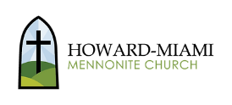

Prayer Request & Praises

* **Pray for those unable to attend –**
  + Alma Bontrager
  + Rosalyn Beachy
  + Clara Chism
  + Pauline Rhine
  + Joyce Dittfield
  + Carson and Verba Engel
* **Prayers for continued Recovery –**
  + Joyce Dittfield
* **Prayers for Health and Other Concerns –**
  + Melody Swart and her family on her breast cancer journey.
  + Grace Howe and her family that she will feel God’s presence in her current struggles.
  + Mark Rosenberger and his family as he is away from his family due to work.
  + Dwain Varnell and his family as he continues to battle renal failure.
  + Shannon Hatton on her recovery from recent surgery.
* **Prayers for the Church and Community –**
  + Our children, youth, & schools
  + That we continue to show love to those around us and Love as Christ Loves.
* **Praises for recent baptisms**